**DATABASE RECOVERY**

**Introduction**

Recovery processes vary depending on the type of failure that occurred, the structures affected, and the type of recovery that you perform. If no files are lost or damaged, recovery may amount to no more than restarting an instance. If data has been lost, recovery requires additional steps

**Purpose of Data Recovery**

Data recovery is the process of restoring data that has been lost, accidentally deleted, corrupted or made inaccessible for any reason. Data recovery typically refers to the restoration of data to a desktop, laptop, server, or external storage system from a backup. The purposes of Data Recovery are:

* Planning and testing responses to different kinds of failures
* Configuring the database environment for backup and recovery
* Setting up a backup schedule
* Monitoring the backup and recovery environment
* Troubleshooting backup problems
* Recovering from data loss if the need arises

## Types of failure

Failures may be

|  |  |
| --- | --- |
| Transaction | Caused by errors within the transaction processes. |
| System | Caused by failure of network or operating system or physical threats to the system as a whole. |
| Media | Failure of hard disk, out of memory errors, out of disk space errors. |

## The Storage Hierarchy

Data are the principal resources of an organization. Data stored in computer systems form a hierarchy extending from a single bit to a database, the major record-keeping entity of a firm. Each higher rung of this hierarchy is organized from the components below it.Data are logically organized into:

Databases are stored in file formats, which contain records. At physical level, the actual data is stored in electromagnetic format on some device. These storage devices can be broadly categorized into three types −

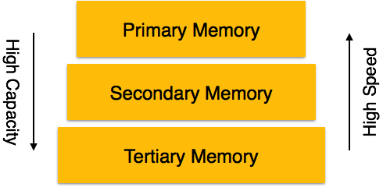

* **Primary Storage** − The memory storage that is directly accessible to the CPU comes under this category. CPU's internal memory (registers), fast memory (cache), and main memory (RAM) are directly accessible to the CPU, as they are all placed on the motherboard or CPU chipset. This storage is typically very small, ultra-fast, and volatile. Primary storage requires continuous power supply in order to maintain its state. In case of a power failure, all its data is lost.
* **Secondary Storage** − Secondary storage devices are used to store data for future use or as backup. Secondary storage includes memory devices that are not a part of the CPU chipset or motherboard, for example, magnetic disks, optical disks (DVD, CD, etc.), hard disks, flash drives, and magnetic tapes.
* **Tertiary Storage** − Tertiary storage is used to store huge volumes of data. Since such storage devices are external to the computer system, they are the slowest in speed. These storage devices are mostly used to take the back up of an entire system. Optical disks and magnetic tapes are widely used as tertiary storage.